

**TRIBHUVAN UNIVERSITY**

**Faculty of Humanities and Social Sciences**

**Ecommerce Application (NepStore)**

**A Project Report**

**Submitted to**

**Department of Computer Application**

**JANAMAITRI MULTIPLE CAMPUS**

***In partial fulfillment of the requirements for the Bachelors in Computer Application***

**Submitted by**

**Manoj Pathak**

**(Redg No: 6-2-263-30-2022)**

**Under the Supervision of**

**Kamal Tamrakar**

**March 2025**



**SUPERVISOR’S RECOMMENDATION**

I hereby recommend that this project has been prepared under my supervision by **Manoj Pathak (Redg No: 6-2-263-30-2022)** entitled "**NepStore" (A Ecommerce platform)** in partial fulfillment of the requirements for the Bachelor's degree of BCA (Bachelor of Computer Application) is recommended for the final evaluation.

**……………………..**

**Kamal Tamrakar**

Supervisor



**LETTER OF APPROVAL**

This is to certify that this project prepared by **Manoj Pathak (Registration No: 6-2-263-30-2022)** entitled " **Nepstore"** in partial fulfillment of the requirements for the bachelor's degree of BCA (Bachelor of Computer Application) has been evaluated. In our opinion it is satisfactory in the scope and quality as a project for the required degree.

|  |  |
| --- | --- |
| **Signature of Supervisor**  **……………………………..**  Kamal Tamrakar  (Supervisor) | **Project & Practicum Committee**  **………………………………**  KamaTamrakar  (Project and Practical Committee) |
| **Signature of Internal Examiner**  **………………………..**  Internal Examiner | **Signature of External Examiner**  **………………………..**  External Examiner |

# ABSTRACT

E-commerce has rapidly reshaped retail worldwide, offering customers convenience, accessibility, and secure transactions. In Nepal, the growing use of the internet, smartphones, and digital wallets has fueled the expansion of online shopping platforms. This project, **NepStore**, presents an online e-commerce application developed using **WordPress and WooCommerce**, designed to sell clothes, shoes, and accessories for men and women.

The system is fully hosted online with **SSL security** and integrates with **eSewa**, Nepal’s leading digital payment gateway, to ensure safe and real-time transactions. Key modules include product management, user accounts, shopping cart, checkout, and order tracking. The platform was tested through unit, system, and payment gateway testing to ensure reliability and accuracy.

NepStore demonstrates the technical feasibility of developing a secure and scalable e-commerce solution in Nepal while promoting the adoption of digital payments and strengthening the local online shopping culture.

***Keywords:*** *E-commerce, WordPress, WooCommerce, NepStore, eSewa, Payment Gateway*

# ACKNOWLEDGEMENT

We would like to express our sincere gratitude to everyone who contributed to the successful development of this project. First, we are grateful to the Department of BCA for their support and resources, which made this project possible.

A special thanks to **Mr. Kamal Tamrakar** Head of the Department at Janamaitri Multiple Campus, for his invaluable guidance, mentorship and valuable feedback throughout the project. His expertise has been essential in shaping our approach and achieving our goals.

Special thanks to **Mrs. Abita Kunwar** for her technical expertise in database management and entity-relationship modeling, which significantly enhanced the overall quality of the project.

Lastly, we are grateful to our families, teachers and friends for their constant support, understanding, and encouragement throughout this journey. Their unwavering support and collaboration were essential to our success.

Sincerely,

**Manoj Pathak**

**Table Of Content**

ACKNOWLEDGEMENT ................................................................. iv  
LIST OF ABBREVIATIONS ......................................................... vii  
LIST OF FIGURES ................................................................. viii

**CHAPTER 1: INTRODUCTION** .................................................. 1  
 1.1 Introduction ................................................................. 1  
 1.2 Problem Statement ......................................................... 1  
 1.3 Objectives ................................................................. 2  
 1.4 Scope and Limitation .................................................... 2  
 1.5 Report Organization .................................................... 3

**CHAPTER 2: BACKGROUND STUDY AND LITERATURE REVIEW** ....... 4  
 2.1 Background Study ......................................................... 4  
 2.2 Literature Review ........................................................ 4

**CHAPTER 3: SYSTEM ANALYSIS AND DESIGN** .......................... 8  
 3.1 System Analysis .......................................................... 8  
  3.1.1 Methodology .......................................................... 8  
  3.1.2 Requirement Analysis ............................................... 9  
   i. Functional Requirement ............................................. 9  
   ii. Non-Functional Requirements ................................... 11  
 3.1.2 Feasibility Analysis ................................................ 12  
 3.1.3 Data Modeling (ER-Diagram) .................................... 14  
 3.1.4 Process Modeling (DFD) ............................................ 16  
 3.2 System Design .......................................................... 19  
  3.2.1 Architectural Design .............................................. 19  
  3.2.2 Database Schema Design .......................................... 20  
  3.2.3 Interface Design (UI / Interface Structure Diagram) .... 20

**CHAPTER 4: IMPLEMENTATION AND TESTING** ...................... 23  
 4.1 Implementation ........................................................ 23  
  4.1.1 Tools Used (CASE tools, Programming language, Database) .. 23  
  4.1.2 Implementation Details of Modules ............................. 25  
 4.2 Testing ................................................................. 27  
  4.2.1 Test Cases for Unit Testing ...................................... 27  
  4.2.2 Test Cases for System Testing .................................. 31  
SYSTEM TEST CASES ......................................................... 31

**CHAPTER 5: CONCLUSION AND FUTURE RECOMMENDATIONS** ..... 34  
 5.1 Lesson Learnt / Outcome ............................................ 34  
 5.2 Conclusion ............................................................ 35  
 5.3 Future Recommendations ............................................ 35

**References** ................................................................. 36  
**APPENDICES** ................................................................. 38

# LIST OF ABBREVIATIONS

CRUD: Create, Read, Update and Delete

CSS: Cascading Style Sheet

DAS: NepStore

DFD: Data Flow Diagram

ERD: Entity Relationship Diagram

HTML: Hyper Text Markup Language

JS: JavaScript

MySQL: My Structured Query Language

PHP: Hypertext Preprocessor

# LIST OF FIGURES

Figure 3.1 Waterfall Model 6

Figure 3.2 Use Case Diagram of NepStore 7

Figure 3.3 Gantt Chart for NepStore 10

Figure 3.4 ER Diagram of NepStore 12

Figure 3.5 Level 0 DFD for NepStore 13

Figure 3.6 Level 1 DFD for NepStore 13

Figure 3.7 Architectural Design of NepStore 14

Figure 3.8 Flow chart of NepStore for Admin 15

Figure 3.9 Flow chart of NepStore for Storekeeper 16

Figure 3.10 Database Schema Design of NepStore 17

Figure 3.11 UI Home page of NepStore 18

Figure 3.12 Login page for NepStore 18

Figure 3.13 Signup page for NepStore 19

Figure 3.14 Dashboard for NepStore 19

Figure 3.15 Physical DFD of NepStore 20

# LIST OF TABLES

Table 3.1 Gantt Chart Table for NepStore 10

Table 4.1 Test Case for Create User of NepStore 26

Table 4.2 Test case for User Login of NepStore 27

Table 4.3 Test Case for New Supplier of NepStore 28

Table 4.4 Test Case for New Inventory of NepStore 28

Table 4.5 Test Case for New Category of NepStore 29

Table 4.6 Test Case for New Customer of NepStore 29

Table 4.7 Test Case for Inventory Module of NepStore 30

Table 4.8 Test Case for Suppliers Module of NepStore 30

Table 4.9 Test Case for Category Module of NepStore 30

Table 4.10 Test Case for Customers Module of NepStore 31

# CHAPTER:1 INTRODUCTION

## 1.1 Introduction

The emergence of e-commerce has transformed global business practices by providing customers with the ability to purchase products and services online from anywhere and at any time. Unlike traditional retail, e-commerce offers convenience, accessibility, and efficiency, thereby reshaping consumer expectations and market dynamics. In Nepal, the adoption of e-commerce has grown rapidly in recent years due to increasing internet penetration, smartphone usage, and the availability of digital wallets such as eSewa and Khalti. This trend reflects a shift in consumer behavior toward online transactions and has created significant opportunities for businesses to expand their reach beyond physical stores.

**NepStore** is an online shopping platform developed to provide users with an efficient and secure medium to purchase clothes, shoes, and accessories for both men and women. The system has been implemented using **WordPress and WooCommerce**, two widely used tools for developing e-commerce applications. Unlike locally hosted platforms, NepStore is deployed on an online hosting server with **SSL security**, ensuring constant availability and secure communication between the application and its users. A major highlight of the system is the integration of the **eSewa payment gateway**, which allows customers to complete transactions safely in real time.

By bringing together a robust content management system, reliable e-commerce plugin, and localized digital payment integration, NepStore represents a complete solution tailored to the needs of Nepali consumers. The project not only fulfills the academic objectives of system design and development but also demonstrates how technology can address practical business needs in a growing digital economy [1], [2].

## 1.2 Problem Statement

Despite the rapid growth of e-commerce in Nepal, many businesses still face challenges in creating user-friendly, secure, and scalable online platforms. Local consumers often prefer familiar payment systems like eSewa, but many online stores either lack this integration or implement it inefficiently. Similarly, issues such as unreliable hosting, lack of SSL security, and poor interface design reduce customer trust and adoption of online shopping platforms.

Another major challenge lies in the limited availability of platforms that cater to local user needs while maintaining professional design and real-time functionality. Customers increasingly expect smooth navigation, quick checkout processes, and instant payment confirmations. Traditional physical stores cannot provide such convenience, while some existing online platforms fail to deliver a fully secure and reliable experience.

NepStore was developed to address these challenges by combining an intuitive user interface, secure hosting, and seamless eSewa payment integration. The system demonstrates how an e-commerce solution can be customized for the Nepalese market, ensuring both usability and trustworthiness for end-users.

## 1.3 Objectives

The primary objective of the project is to design and implement a fully functional e-commerce platform that meets the needs of Nepali consumers. The specific objectives include:

* To develop an online store using **WordPress and WooCommerce** for managing products, customers, and orders.
* To implement **eSewa payment integration** to enable secure and real-time digital transactions.

## 1.4 Scope and Limitation

The scope of this project encompasses the complete development of an online shopping system for clothes, shoes, and accessories. The system includes modules for product management, customer account creation, shopping cart functionality, checkout, and order tracking. The inclusion of **eSewa integration** provides localized payment support, making the platform more relevant to Nepali users. Additionally, the project emphasizes usability, scalability, and security through the use of SSL encryption and cloud hosting.

However, the system also has certain limitations. At present, NepStore supports only a **single payment option (eSewa)**, whereas in future, additional gateways such as Khalti, FonePay, or PayPal could be integrated. The system is also designed primarily for **retail customers**, and multi-vendor functionality is not included in this version. Furthermore, while the system ensures responsiveness for desktop and mobile devices, more advanced features such as personalized recommendations, AI-powered customer support, and loyalty programs remain outside the current scope.

## 1.5 Report Organization

**1.5.1 Introduction**

This chapter introduces the NepStore, providing an overview of the project's objectives, scope, and limitations. It also discusses the rationale behind the development of the system and the significance of its creation.

**1.5.2 Background Study and Literature Review**

In this chapter, previous research and work related to ecommerce are explored. It highlights the features and functionalities of existing applications and websites in the domain of animal adoption, providing a contextual background for the development of this system.

**1.5.3 Requirement Analysis and System Design**

This chapter focuses on the different requirements of the system, which describes the functional, non-functional, feasibility analysis, Entity Relational diagram, Data Flow Diagram, design of the system with system architecture, database schema, and interface Design.

**1.5.4 Implementation and Testing**

This chapter emphasizes tools used in system development, implementing details and result of test performed.

**1.5.5 Conclusion**

This chapter summarizes the lessons learned throughout the development process. It highlights the outcomes of the project, the objectives achieved, and the functionality delivered. Additionally, it discusses potential areas for future improvements and enhancements to the system

# CHAPTER 2: BACKGROUND STUDY AND LITERATURE REVIEW

## 2.1 Background Study

The rise of e-commerce has revolutionized the retail industry worldwide by enabling businesses to sell products and services through digital platforms. This paradigm shift has been supported by the increasing use of the internet, smartphones, and online banking facilities. Globally, e-commerce has grown into a multi-trillion-dollar industry, with platforms such as Amazon, eBay, and Alibaba leading the transformation of consumer behavior from traditional retail purchases to online shopping [1].

In Nepal, the growth of e-commerce has been relatively recent but promising. The expansion of internet penetration, coupled with improved digital literacy and the availability of mobile payment systems, has created an environment conducive to online retail. Popular Nepali platforms such as Daraz and SastoDeal have already demonstrated the potential of e-commerce in the local market. However, despite this growth, challenges remain, including limited trust in digital platforms, the preference for cash-on-delivery, and the absence of secure, localized payment integration in many systems [2].

With the increasing adoption of digital wallets, particularly **eSewa** and **Khalti**, the local population is gradually shifting toward cashless transactions. eSewa, developed by F1Soft International, is Nepal’s leading mobile wallet and digital payment system, widely used for utility payments, mobile recharges, and online shopping. Its reliability, compliance with Nepal Rastra Bank regulations, and familiarity among consumers make it an essential component of any e-commerce system targeted at the Nepalese market [3]. NepStore leverages this payment system to provide a seamless checkout experience, thereby overcoming one of the key challenges of digital adoption.

Thus, the background of this project lies in the convergence of global e-commerce trends, local technological advancements, and the need for customized platforms that integrate user-friendly interfaces with trusted digital payment solutions.

## 2.2 Literature Review

Several studies and research works have explored the development, adoption, and impact of e-commerce systems worldwide. According to Laudon and Traver [4], e-commerce frameworks rely heavily on robust content management systems, user-centric design, and secure payment gateways to ensure both usability and trustworthiness. WordPress and WooCommerce have been widely adopted as tools for developing small-to-medium-scale e-commerce platforms due to their flexibility, scalability, and extensive plugin support. WooCommerce, in particular, allows integration with third-party payment providers, enabling businesses to customize platforms for specific markets.

In the context of digital payment adoption, studies by Chaffey [5] emphasize that secure and convenient payment gateways are one of the most critical success factors for online businesses. Customers tend to abandon carts or avoid online shopping entirely if payment systems are perceived as unreliable or unsafe. In countries like Nepal, the availability of localized solutions such as eSewa provides businesses with an advantage, as customers are more willing to trust familiar systems compared to global gateways like PayPal or Stripe, which often involve foreign currency transactions.

Existing platforms in Nepal, such as Daraz, have set benchmarks for e-commerce by offering wide product ranges and reliable delivery systems. However, smaller businesses face challenges in replicating such systems due to limited technical expertise and lack of resources. Research highlights that platforms built on CMS frameworks like WordPress offer a viable solution for such businesses, as they significantly reduce development costs and provide pre-built modules for product management, cart systems, and order handling [6].

Furthermore, the literature underlines the importance of testing and quality assurance in e-commerce systems. Pressman and Maxim [7] stress that structured testing approaches—including unit, system, and integration testing—are essential to ensure functionality, performance, and security. This aligns with NepStore’s development process, where extensive testing was conducted to validate its modules, including the critical eSewa payment gateway integration.

Overall, the literature suggests that the success of an e-commerce system depends on three primary factors: a robust platform for development, secure and trusted payment integration, and rigorous testing for quality assurance. NepStore incorporates these elements, thereby providing both academic and practical contributions to the study and implementation of e-commerce platforms in Nepal.

# CHAPTER 3 SYSTEM ANALYSIS AND DESIGN

## 3.1 System Analysis

NepStore was developed through a structured process involving requirement analysis, design, implementation, testing, and maintenance. Both functional and non-functional requirements were identified and used to design the system. Development was carried out in iterative cycles, allowing testing and refinement at each stage. Errors identified during testing were corrected immediately, and the system was improved continuously. Once validated, the system was deployed and maintained to ensure reliability and scalability.

### 3.1.1 Methodology

The project followed the **Agile methodology**, which emphasizes iterative and incremental development. Work was divided into short cycles (*sprints*), where specific features such as product management, checkout, or eSewa integration were developed and tested. This approach allowed flexibility to adapt to changes, continuous feedback from stakeholders, and early detection of errors. Agile was chosen over the Waterfall model because it ensured faster adaptability, better quality through continuous testing, and closer alignment with user needs.

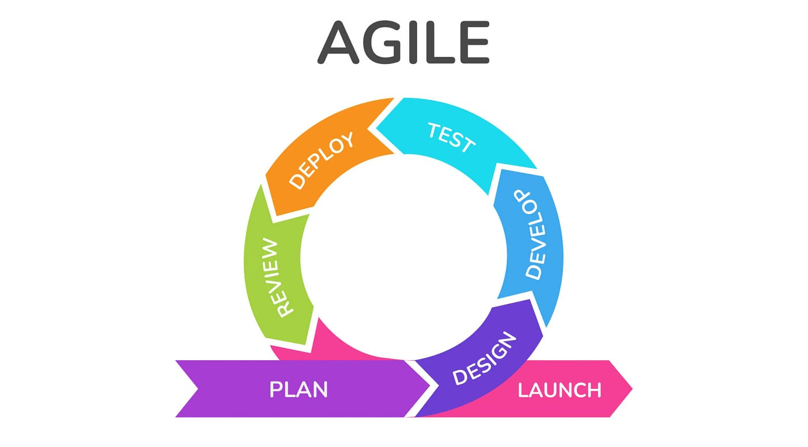

**Figure 3.1:Agile Methodology**

### 3.1.2 Requirement Analysis

The system's requirements are divided into two main categories: **Functional Requirements** and **Non-Functional Requirements**. Below is the detailed analysis for the functional requirements.

### i.Functional Requirement

The functional requirements define the core services and operations NepStore must provide:

* Users must be able to **register, log in, and manage their accounts**.
* Customers can **browse, search, and filter products** such as clothes, shoes, and accessories.
* The system must support a **shopping cart** where users can add, update, or remove products.
* Customers can **place orders** and proceed to checkout.
* The platform must integrate with **eSewa** for secure online payments.
* The system should allow **administrators to add, edit, and delete products**.
* The admin dashboard must support **order management and sales tracking**.
* Users should receive **order confirmations and status updates**.

### ii.Non-Functional Requirements

Different non-functional requirement have been studied and identified and are listed as below:

* + **Performance:-** The performance of the system is fast and accurate as it provide fast response to the user’s actions. The system handle expected and unexpected errors and also large amount of data.
  + **Usability:-**This system provides help and support menu in all interface for user to interact with the system. The user can use the system by reading and support.
  + **Security**:- The system provides username and password during login to prevent any unauthorized access. This helps to provide security and privacy to both service provider and client.
  + **Availability**:- The system is available for access at 24 hours and 7 days a week. Also, in the occurrence of any malfunctioning, the admin should notify the user and minimum 1-2 working days so that the business is not severely affected.

### 3.1.2 Feasibility Analysis

A feasibility study was conducted to evaluate the practicality of developing NepStore. The study focused on four main dimensions:

* **Technical Feasibility:** NepStore was developed using WordPress and WooCommerce, which are widely supported technologies with large communities and resources. Integration with eSewa was made possible through available APIs and plugins, making the system technically viable.
* **Operational Feasibility:** The system addresses real-world problems such as limited trust in digital platforms by providing secure and reliable payment processing. Its user-friendly interface ensures customers can complete purchases easily, making it operationally practical.
* **Economic Feasibility:** As an open-source solution, WordPress and WooCommerce significantly reduce development costs compared to building an application from scratch. Hosting costs and payment gateway fees are manageable, making the project cost-effective.
* **Legal Feasibility:** The integration with eSewa ensures compliance with Nepal Rastra Bank’s regulations on digital payments. Additionally, SSL certification provides compliance with data protection and online security standards [2].

The study confirmed that NepStore is feasible in all dimensions and capable of meeting the objectives of a localized e-commerce platform.

|  |  |  |  |  |  |
| --- | --- | --- | --- | --- | --- |
| ID | Task Name | Start | Finish | Duration | Status |
| 1 | Planning | 8/01/2024 | 08/06/2024 | 6 days | Completed |
| 2 | Analysis | 08/07/2024 | 09/06/2024 | 30 days | Completed |
| 3 | System Design | 09/07/2024 | 10/8/2024 | 42 days | Completed |
| 4 | Development | 10/19/2024 | 12/06/2024 | 40 days | Completed |
| 5 | Testing | 12/07/2024 | 12/12/2025 | 13days | Completed |
| 6 | Documentation | 08/01/2024 | 2/28/2025 | Start to End | Completed |

**Table 3.1 Gantt Chart Table for NepStore**

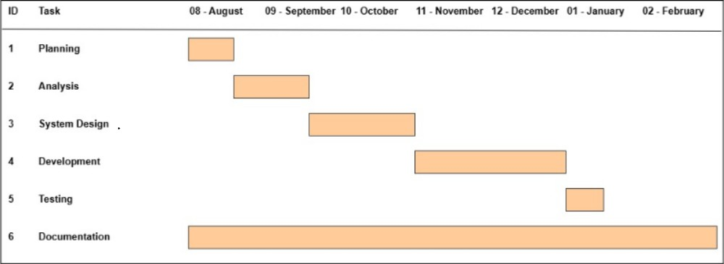

**Figure 3.3:Gantt chart for NepStore**

This Gantt chart for the NepStore illustrates the project's timeline and highlights the key phases required for its development and implementation. The project begins with the Planning phase, lasting 6 days, where the objectives, scope, and resources are outlined to provide a structured approach. This is followed by the Analysis phase, which spans 30 days, focusing on gathering requirements, studying existing systems, and understanding user needs. The System Design phase, lasting 42 days, involves creating detailed designs, including system architecture, database schemas, and user interfaces, serving as a blueprint for the system. Subsequently, the Development phase runs for 40 days, during which the system's functionalities are implemented and integrated. The Testing phase follows, lasting 6 days, where the system undergoes rigorous testing to ensure it meets quality standards and resolves any issues. Finally, the Documentation phase runs throughout the entire project, capturing essential details like requirements, user guides, and reports, ensuring proper records and facilitating future improvements. This structured timeline ensures efficient task management and successful completion of the NepStore..

## 3.2 System Design

The system design of NepStore consists of architectural design, database schema design, user interface design and physical DFD are shown as follows:

### 3.2.1 Architectural Design

The architecture of NepStore follows a **three-tier model**:

1. **Presentation Layer (Front-End):** Implemented using WordPress themes, providing the user interface for customers and admins. It includes product pages, shopping cart, and checkout interface.
2. **Application Layer (Back-End):** Managed through WooCommerce and integrated plugins. This layer handles business logic, including order processing, cart management, and payment requests to eSewa.
3. **Database Layer:** Implemented using MySQL, where customer data, product details, orders, and payment records are securely stored.

Additionally, the **payment integration architecture** involves communication between WooCommerce and the eSewa API. When a payment request is initiated, details are sent to eSewa, which validates the transaction and sends a callback response to update the order status in NepStore.

**Figure 3.12: Three Tier Architecture of  *NepStore***

### 3.2.3 Interface Design (UI Interface / Interface Structure Diagram)

The user interface design focuses on simplicity and usability, ensuring that users can easily navigate and perform necessary actions. The primary interfaces include:

* Registration and Login Page: Users can register and login to their account.
* Dashboard: Users can view and manage their adoption and donation request.
* Request Creation page: sellers/admin can add and create new dogs.
* Request viewing Page: Buyers can view available dog adoption request.
* Admin dashboard: Admins can manage user profiles, request and cancel.

The interface design was implemented using PHP, CSS, JavaScript to provide a

dynamic and responsive user experience.

**User Interface:** 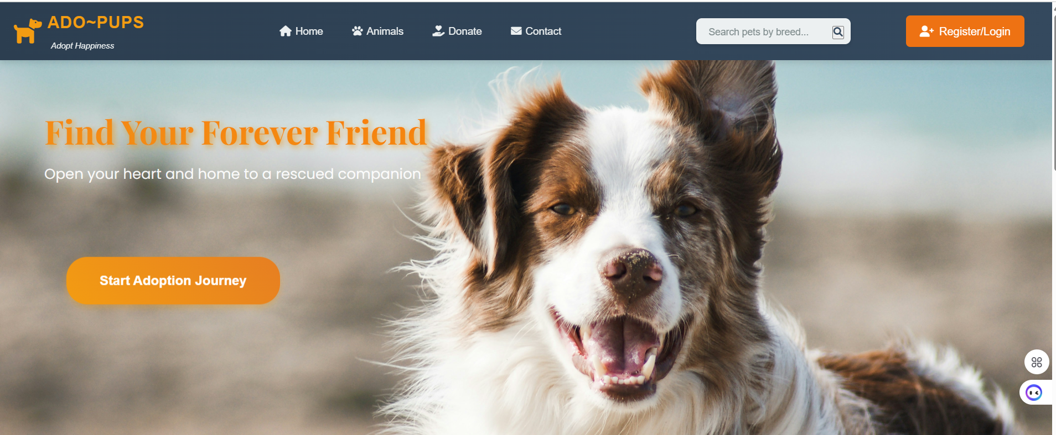

**Figure 3.14:UI Home page of NepStore**

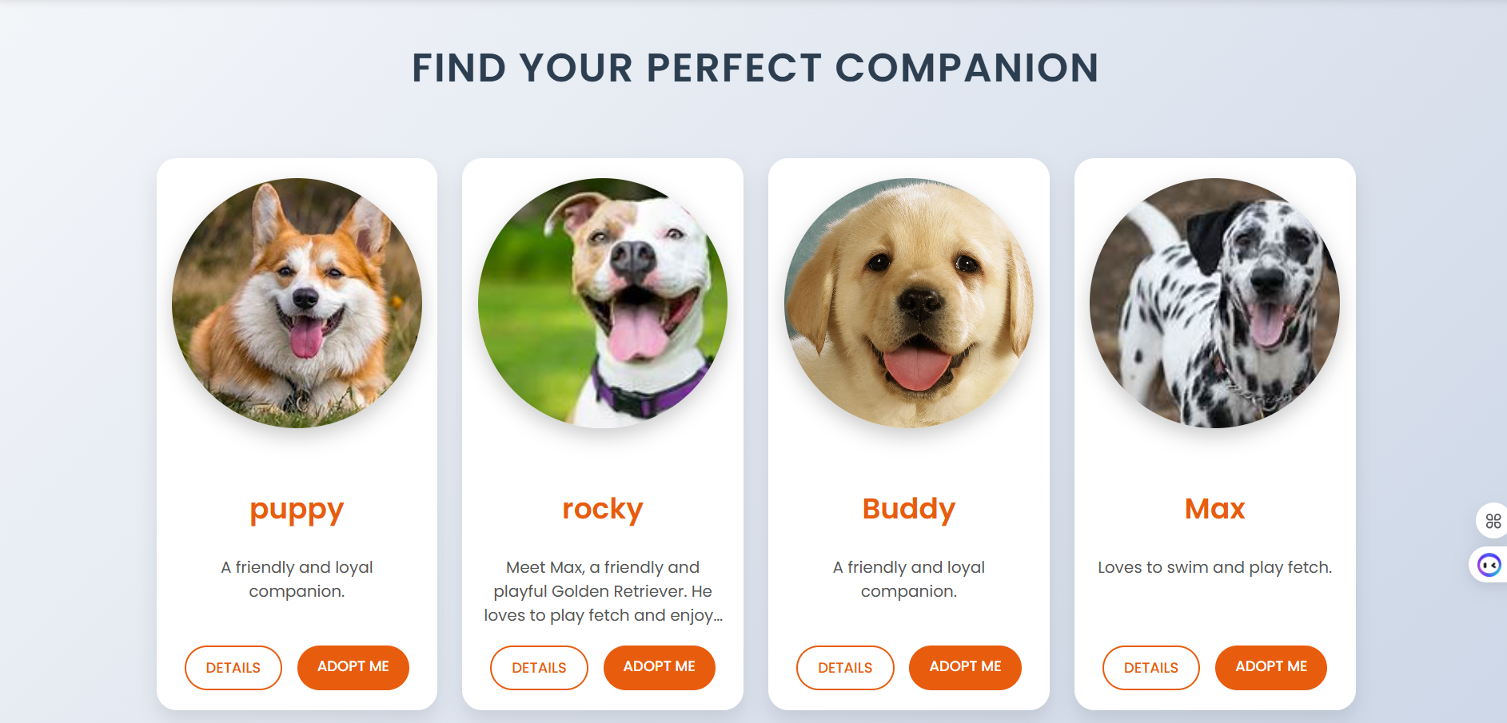

**Figure 3.15:Animal page for NepStore**

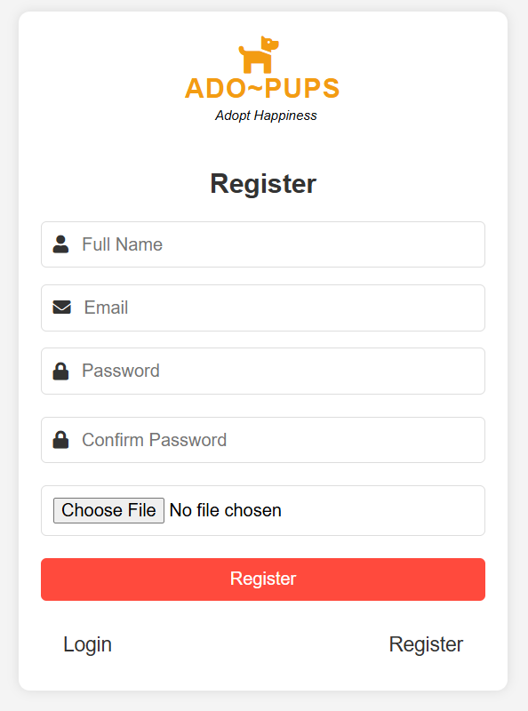

**Figure 3.16:Signup page for NepStore**

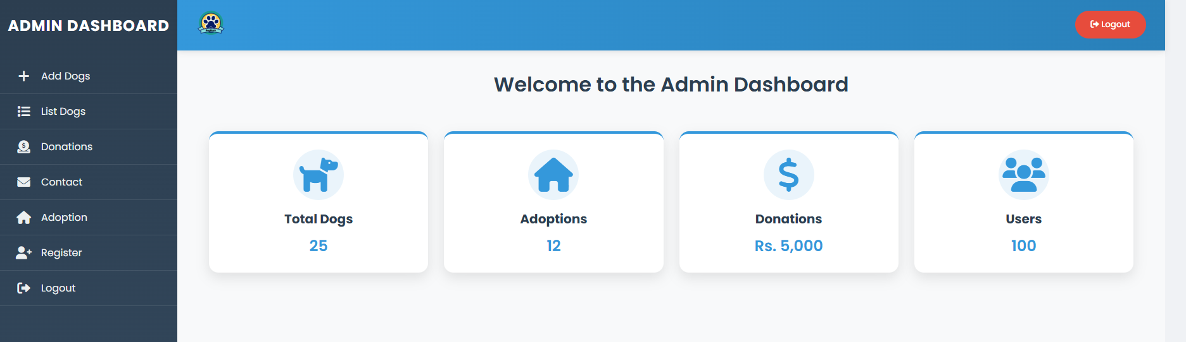

**Figure 3 .17:Dashboard for NepStore**

# CHAPTER 4: IMPLEMENTATION AND TESTING

## 4.1 Implementation

The implementation phase of NepStore represents the transition of the conceptual design into a fully functional e-commerce application. NepStore is built using **WordPress** as the content management system (CMS) and **WooCommerce** as the primary e-commerce framework. This combination enables robust management of products, customer accounts, orders, and payments while leveraging WordPress’s flexibility in customization and plugin integration. WooCommerce was selected for its scalability, open-source nature, and strong community support, which ensures long-term maintainability [1].

### 4.1.1 Tools Used (CASE tools, Programming language, Database platforms)

The successful development of NepStore required a set of interconnected tools, frameworks, and plugins:

* **WordPress CMS:** Provided the backbone for content management and user authentication.
* **WooCommerce Plugin:** Enabled core e-commerce functionalities such as product listings, cart management, checkout processes, and order tracking.
* **eSewa Payment Gateway Plugin:** Facilitated online payments, integrated using merchant credentials and secure API connections.
* **MySQL Database:** Managed user accounts, order records, product data, and payment logs within WordPress’s backend.
* **Apache Web Server:** Delivered dynamic WordPress pages and processed backend requests.
* **Security Tools:** SSL encryption and WordPress security plugins such as Wordfence were deployed to mitigate vulnerabilities.
* **Version Control:** GitHub was used to track theme modifications and custom plugin configurations.
* **Documentation Tools:** Microsoft Office and Draw.io were employed for preparing technical documentation and system design diagrams.

### 4.1.2 Implementation Details of Modules (Description of procedures/functions)

The NepStore platform was developed modularly, ensuring maintainability and future scalability. Key modules include:

* **User Management Module:** Handles customer registration, authentication, and account management using WordPress’s role-based access system.
* **Product Catalog Module:** Allows administrators to create and manage product listings with details such as descriptions, prices, categories, and images.
* **Shopping Cart and Checkout Module:** Enables users to add products to their cart, apply discount codes, and proceed through a multi-step checkout process.
* **Order Management Module:** Provides administrators with order tracking features, including pending, processing, completed, and canceled statuses.
* **Donation/Support Module (Optional):** Designed for future integration, this will allow customers to provide direct financial contributions to support business operations or causes.

**4.1.3 Payment Integration with eSewa**

The most significant implementation feature of NepStore is the **integration of the eSewa digital wallet** for secure and real-time payment processing. As Nepal’s leading digital payment gateway, eSewa supports both wallet-to-wallet transfers and bank-linked payments, making it a reliable solution for e-commerce businesses [4].

**Technical Integration Process**

Payment integration was achieved using the **WooCommerce eSewa Payment Gateway plugin**, configured with the Merchant ID and Secret Key provided by eSewa. The plugin establishes communication with eSewa’s **RESTful API**, which allows the system to securely process payments.

The sequence of a typical transaction is as follows:

1. **Order Initialization:** When a customer selects eSewa at checkout, WooCommerce generates an order ID and sends transaction details (merchant code, product ID, transaction amount, and callback URL) to eSewa’s payment gateway.
2. **User Authentication and Payment:** The customer logs into their eSewa wallet and authorizes the payment. eSewa validates the account balance, user credentials, and requested payment.
3. **Transaction Confirmation:** Once the transaction is successful, eSewa sends a **callback response** to NepStore’s server with transaction details and a confirmation code.
4. **Order Status Update:** WooCommerce verifies the callback data. If valid, the order status is automatically updated to “Completed.” In case of failure, the status is marked as “Failed” or “Pending,” allowing users to retry.
5. **Receipt Generation:** Customers receive an on-screen confirmation along with an email receipt generated by WooCommerce.

**Security and Validation**

To ensure secure transactions, **checksum validation** is applied on all transaction requests and responses. This prevents unauthorized alterations to payment data during transfer. Additionally, SSL encryption guarantees that sensitive information, such as transaction IDs and user credentials, is securely transmitted. These practices align with global e-commerce standards for online payment security [5].

**Benefits of Integration**

The integration of eSewa enhances NepStore in multiple ways:

* Provides a **localized payment solution**, increasing adoption among Nepali customers.
* Ensures **real-time order confirmation**, reducing delays in transaction processing.
* Enhances **trust and transparency** by offering receipts and instant verification.
* Supports future scalability, as the same gateway can be extended to handle refunds or loyalty points.

Thus, the successful integration of eSewa transforms NepStore from a simple online catalog into a fully functional e-commerce platform capable of conducting secure and automated financial transactions.

## 4.2 Testing

System testing was performed using various scenarios to validate that NepStore operates reliably under real-world conditions. The testing process included both unit testing of individual modules and system testing of integrated workflows. Each test case was carefully designed to ensure the platform meets functional and non-functional requirements.

**4.2.1 Test Cases for Unit Testing**

Unit testing refers to testing each modular component of NepStore independently. This ensured that functionalities such as user authentication, cart operations, and payment integration worked correctly in isolation.

**Table 4.1: Test Case for Login Validation of NepStore**

|  |  |
| --- | --- |
| Test Case ID | TC-U001 |
| Objective | To ensure users cannot access checkout without logging in. |
| Test Steps | 1. Navigate to checkout page without login. 2. System redirects to login page. |
| Input Data | Guest user (not logged in). |
| Expected Results | Redirected to login/registration page. |
| Actual Results | System prevents access and redirects to login page. |
| Test Environment | Windows 10, Chrome Browser |
| Execution Status | Pass |

**Table 4.2: Test Case for Invalid Login Validation of NepStore**

|  |  |
| --- | --- |
| Test Case ID | TC-U002 |
| Objective | To verify the system denies invalid login attempts. |
| Test Steps | 1. Enter incorrect email and password. 2. Attempt login. |
| Input Data | Email: user@test.com, Password: wrong123 |
| Expected Results | Error message: 'Invalid username or password.' |
| Actual Results | Access denied, error message displayed. |
| Test Environment | Windows 10, Chrome Browser |
| Execution Status | Pass |

**Table 4.3: Test Case for Cart Functionality in NepStore**

|  |  |
| --- | --- |
| Test Case ID | TC-U003 |
| Objective | To verify that users can add products to the cart successfully. |
| Test Steps | 1. Login as registered user. 2. Select a product and add to cart. 3. View cart. |
| Input Data | Product: Shoes (ID: 101) |
| Expected Results | Product successfully added to cart. |
| Actual Results | Item displayed in cart with correct details. |
| Test Environment | Windows 10, Chrome Browser |
| Execution Status | Pass |

**Table 4.4: Test Case for eSewa Payment (Valid Transaction)**

|  |  |
| --- | --- |
| Test Case ID | TC-U004 |
| Objective | To ensure successful order placement with valid eSewa payment. |
| Test Steps | 1. Add product to cart. 2. Proceed to checkout. 3. Select eSewa and authorize payment. |
| Input Data | Product: Jacket (ID: 202), Amount: NPR 2500 |
| Expected Results | Order placed, transaction successful, confirmation email sent. |
| Actual Results | Payment processed and order status updated to 'Completed'. |
| Test Environment | Windows 11, Chrome Browser |
| Execution Status | Pass |

**Table 4.5: Test Case for eSewa Payment (Invalid Transaction)**

|  |  |
| --- | --- |
| Test Case ID | TC-U005 |
| Objective | To validate error handling for failed transactions. |
| Test Steps | 1. Add product to cart. 2. Proceed to checkout. 3. Enter incorrect eSewa details. |
| Input Data | eSewa ID: wrong123, Amount: NPR 1500 |
| Expected Results | Transaction declined, error message shown. |
| Actual Results | Payment failed, order status marked as 'Pending Payment'. |
| Test Environment | Windows 11, Chrome Browser |
| Execution Status | Pass |

**4.2.2 Test Cases for System Testing**

System testing validated the end-to-end functionality of NepStore, ensuring that the integration between user interface, WooCommerce modules, and the eSewa payment gateway functioned as expected.

**Table 4.6: Test Case for Complete Purchase Workflow (Valid)**

|  |  |
| --- | --- |
|  |  |
| Test Case ID | TC-S001 |
| Objective | To verify that the purchase process works correctly from cart to payment confirmation. |
| Test Steps | 1. User logs in. 2. Adds product to cart. 3. Proceeds to checkout. 4. Pays via eSewa. 5. Order confirmed. |
| Input Data | User ID: 1, Product ID: 303 (Shoes), Amount: NPR 2000 |
| Expected Results | Order confirmed, payment successful, confirmation email sent. |
| Actual Results | Request approved, payment verified, order completed. |
| Test Environment | Windows 11, Chrome Browser |
| Execution Status | Pass |

**Table 4.7: Test Case for Complete Purchase Workflow (Invalid)**

|  |  |
| --- | --- |
|  |  |
| Test Case ID | TC-S002 |
| Objective | To ensure system handles failed purchase attempts. |
| Test Steps | 1. User logs in. 2. Adds product to cart. 3. Attempts payment with invalid eSewa ID. |
| Input Data | User ID: 1, Product ID: 404 (Jacket), Amount: NPR 3000 |
| Expected Results | Error: 'Payment failed. Please retry.' |
| Actual Results | Payment declined, order marked as 'Pending Payment'. |
| Test Environment | Windows 11, Chrome Browser |
| Execution Status | Pass |

**Table 4.8: Test Case for Admin Order Management**

|  |  |
| --- | --- |
|  |  |
| Test Case ID | TC-S003 |
| Objective | To verify that admin can view and update orders. |
| Test Steps | 1. Admin logs in. 2. Views new orders. 3. Updates order status. |
| Input Data | Order ID: 5001, Status: Processing → Completed |
| Expected Results | Order successfully updated in dashboard. |
| Actual Results | Admin updated order, customer notified via email. |
| Test Environment | Windows 11, Chrome Browser |
| Execution Status | Pass |

# CHAPTER 5: CONCLUSION AND FUTURE RECOMMENDATIONS

## 5.1 Lesson Learnt / Outcome

The development of NepStore has provided significant insights into both the technical and managerial aspects of implementing an e-commerce platform tailored for the Nepali market. From a technical perspective, the project enhanced the team’s proficiency in configuring **WordPress** and **WooCommerce**, integrating third-party plugins, and ensuring secure payment processing with **eSewa**. The process of connecting the payment gateway with WooCommerce required a deep understanding of API calls, callback verification, and transaction validation, which contributed greatly to practical knowledge of secure digital payments.

From a managerial standpoint, the project demonstrated the importance of **planning, requirement analysis, and modular development**. The iterative approach allowed continuous testing of modules such as product management, cart operations, and payment workflows. This ensured that errors were identified and corrected at an early stage, ultimately leading to a more reliable system. The integration of security measures, including SSL certificates and user authentication, highlighted the need for **trust and reliability in digital commerce**, especially in contexts where customer adoption is closely linked to confidence in secure transactions.

Another important outcome was the realization of the role of **localization in technology adoption**. By choosing eSewa, a payment gateway widely trusted in Nepal, NepStore demonstrated the critical importance of aligning technical solutions with local user preferences. This ensured that the platform not only met global e-commerce standards but also addressed the unique expectations of its target market.

## 5.2 Conclusion

In conclusion, NepStore successfully achieved its objectives of designing and implementing an **online e-commerce platform** that sells accessories, clothes, and shoes for both men and women. The system has been developed with a strong focus on usability, security, and scalability. By leveraging WordPress and WooCommerce, NepStore provided a feature-rich platform capable of handling product listings, customer management, cart operations, and order processing.

## 5.3 Future Recommendations

Although NepStore achieved its primary goals, several improvements and enhancements can be incorporated to strengthen the system in the future:

**1. Integration of Multiple Payment Gateways:**  
While eSewa provides a reliable local solution, the integration of additional gateways such as **Khalti, FonePay, or PayPal** would increase flexibility for customers and attract a wider user base. Supporting international payment systems could also expand NepStore’s reach to customers outside Nepal.

**2. Development of Mobile Applications:**  
A dedicated **Android and iOS application** would improve accessibility and user engagement. Mobile apps with push notifications, personalized product recommendations, and quick checkout would make the shopping experience more convenient for customers.

**3. AI-Powered Product Recommendation System:**  
By integrating **machine learning algorithms**, NepStore can analyze customer behavior and recommend products based on purchase history, browsing patterns, and preferences. This would enhance personalization and potentially increase sales.

**4. Scalability and Cloud Hosting:**  
Deploying the system on **cloud platforms** such as AWS, Azure, or Google Cloud would enhance scalability and performance, ensuring that NepStore can handle high traffic volumes during peak sales seasons.

**5. Enhanced Security Measures:**  
Future improvements could include **two-factor authentication (2FA)** for customers and administrators, along with more advanced encryption mechanisms to safeguard transactions. This would further enhance customer trust and reduce the risk of cyberattacks .

**6. Multi-Vendor Marketplace:**  
Expanding NepStore into a **multi-vendor platform** would allow third-party sellers to register and sell products through the same portal, creating a broader marketplace ecosystem similar to Daraz or Amazon.

# References

|  |  |
| --- | --- |
| [1] | K.S.Davis, "Digital Transformation in Pet Adoption: A Technological Perspective," *Journal of Animal Welfare Technology,* vol. 45, no. 3, pp. 112-124, 2020. |
| [2] | I. Sommerville, Software Engineering, 10th ed., Pearson, 2015. |
| [3] | Petfinder, "Find Your New Best Friend," 2023. [Online]. Available: https://www.petfinder.com/. [Accessed 10 Mar 2025]. |
| [4] | J. Anderson, "Financial Management in Animal Welfare Organizations: The Role of Digital Donations," *Animal Welfare Economics Review,* vol. 18, no. 4, pp. 145-159, 2021. |
| [5] | Adopt-a-Pet, "Adopt a Pet | Find Your New Best Friend," 2023. [Online]. Available: https://www.adoptapet.com/. [Accessed 10 Mar 2025]. |
| [6] | R. J. a. M. White, "Challenges and Opportunities in Online Pet Adoption Platforms," *International Journal of Web-Based Systems,* vol. 32, no. 1, pp. 56-78, 2019. |
| [7] | B. C. UK, "Rehome a Pet | Blue Cross," 2023. [Online]. Available: https://www.bluecross.org.uk/. [Accessed 10 Mar 2025]. |
| [8] | B. Shneiderman, Designing the User Interface: Strategies for Effective Human-Computer Interaction, Pearson, 2016. |
| [9] | S. Care, "Dog Rescue and Adoption in Nepal," 2023. [Online]. Available: https://www.snehacare.org/. [Accessed 10 Mar 2025]. |
| [10] | ASPCA, " Online Adoption Platform Impact Study," 2021. |
| [11] | J. Nielsen, "Usability Engineering in Digital Pet Adoption Platforms," *International Journal of Human-Computer Studies,* vol. 67, no. 4, pp. 256-270, 2019. |
| [12] | P. Smith, "Cybersecurity and Donor Trust in Online Fundraising," *Journal of Web Security,* vol. 22, no. 2, pp. 75-91, 2022. |
| [13] | B. Schneier, Applied Cryptography: Protocols, Algorithms, and Source Code in C, 2nd ed., Wiley, 2015. |

# APPENDICES

1. **Landing Page**



1. **Registration Page**



1. **Login Page**

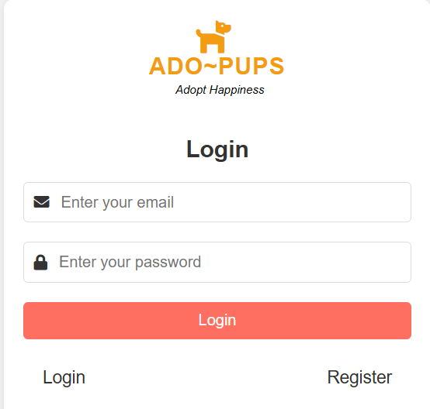

1. **Animal page**



1. **Donation Page**

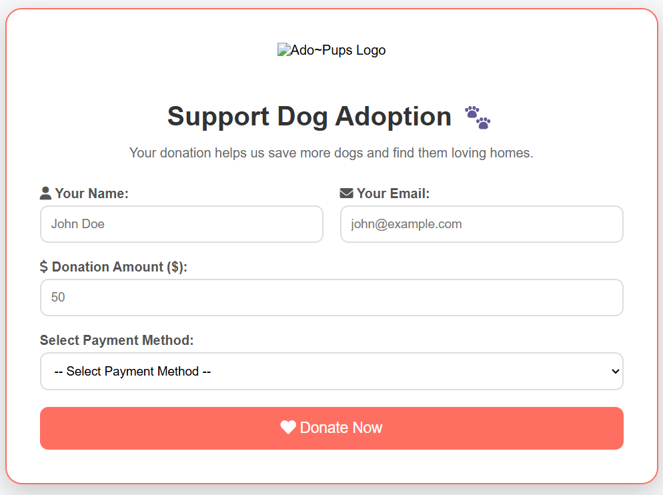

1. **Admin Dashboard**



1. **Contact Page**

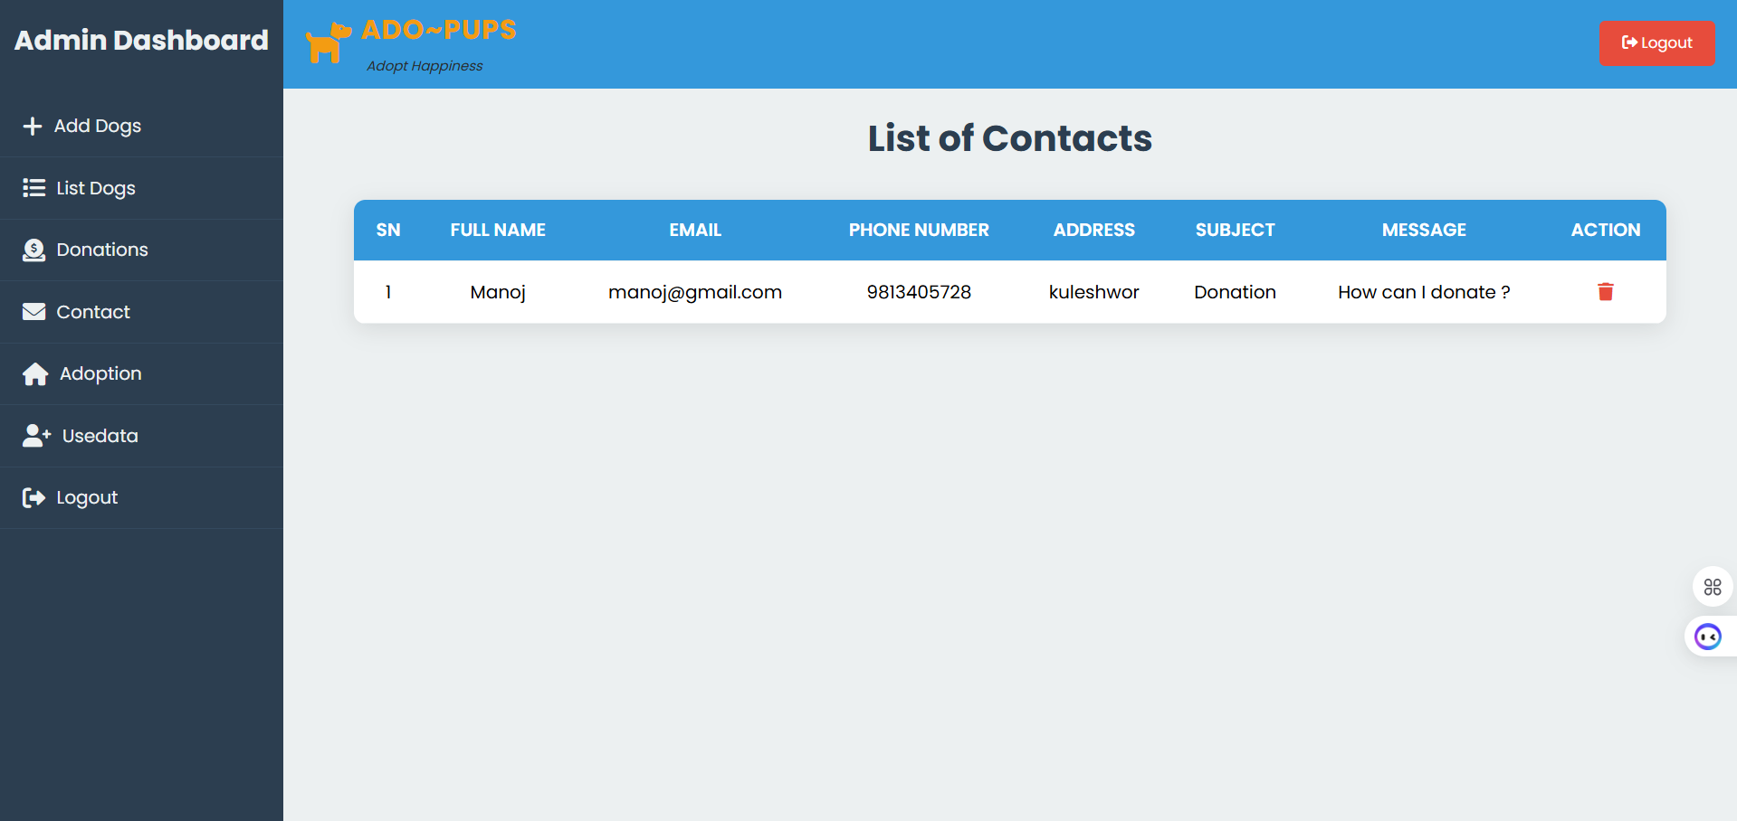

1. **Add Dogs Page**

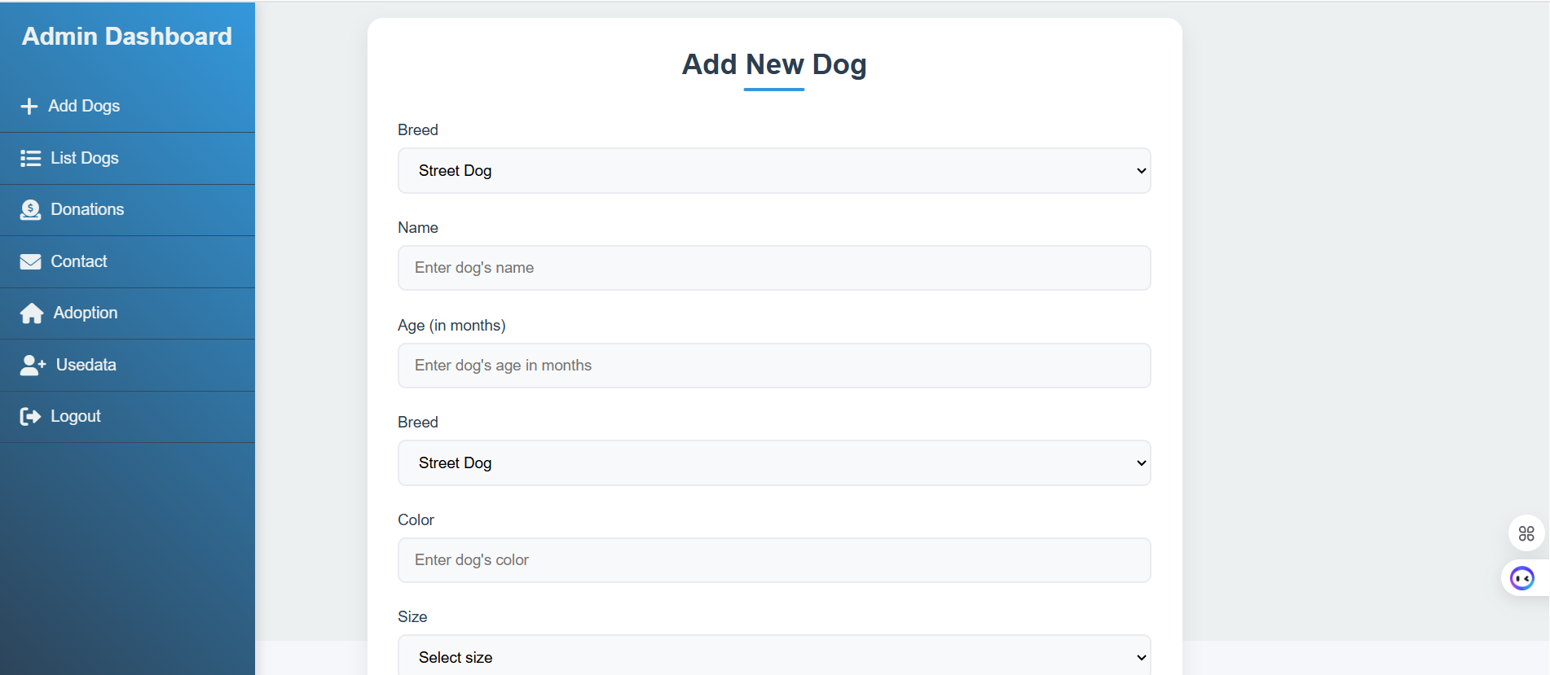

1. **List of Dog Page**

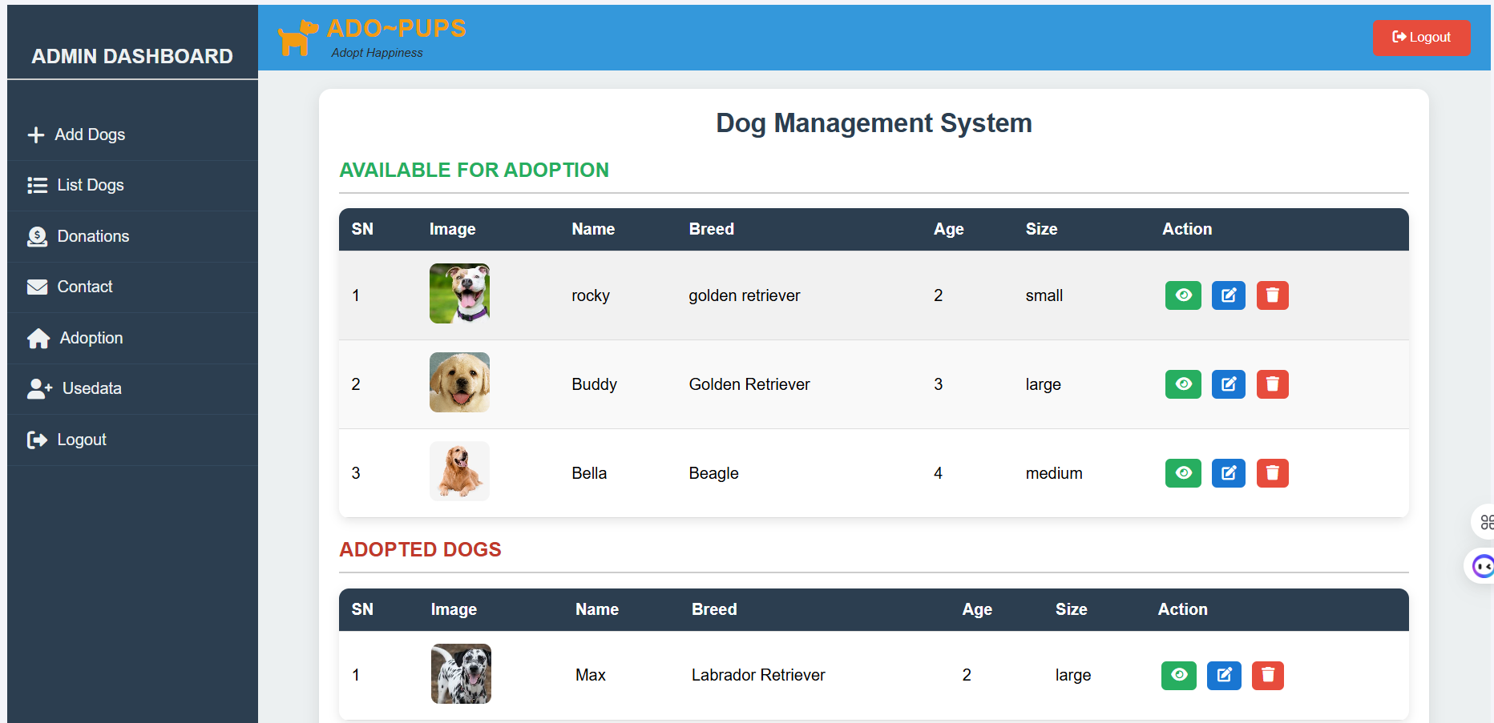

1. **Adoption Application Review Page**

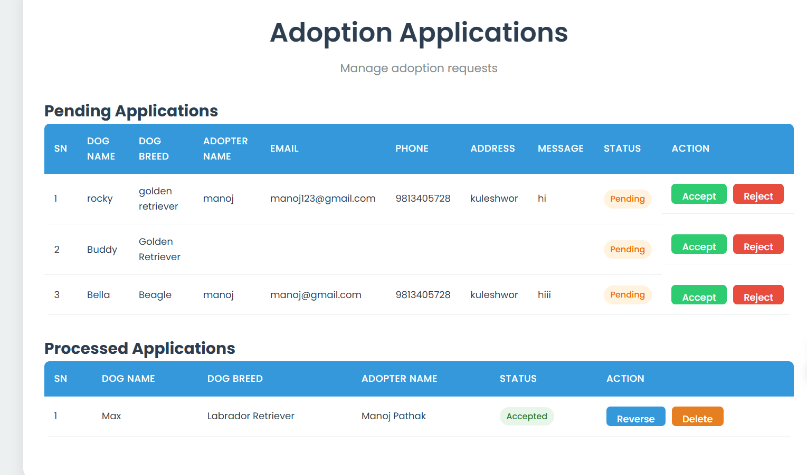

1. **Donation Review Page**

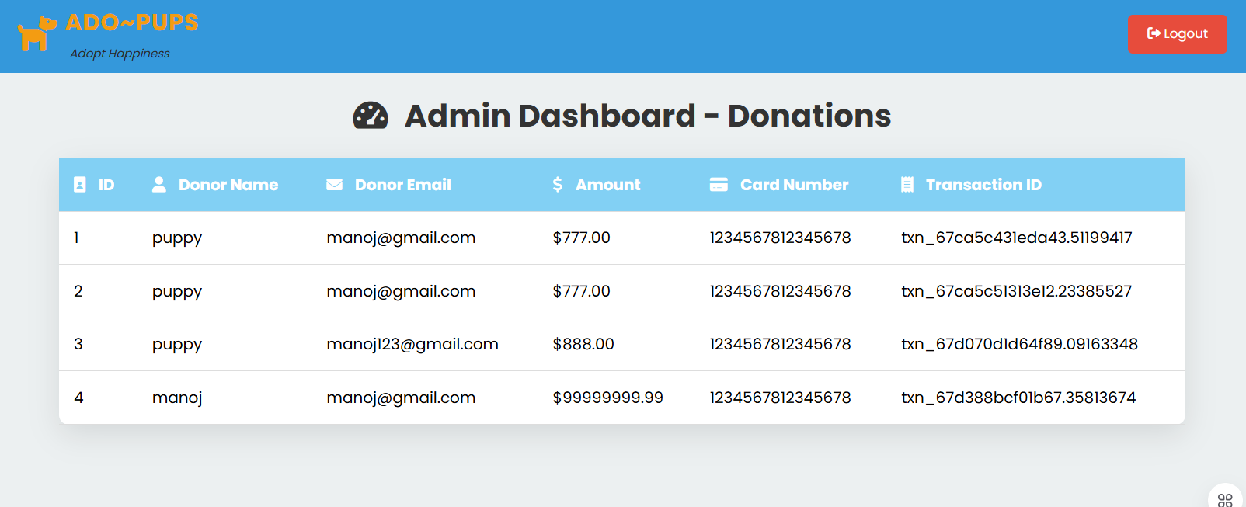

1. **User Management Page**

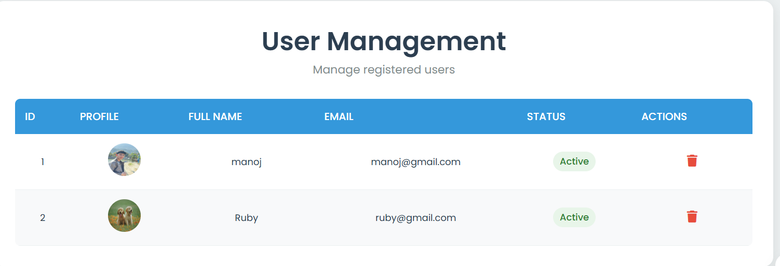

1. **Contact Page**

